A Project Report On

**Event Management System**

Submitted in partial fulfillment of the requirement for the award of the degree of Diploma Computer Engineering, Gujarat Technological University

Submitted by:

**Parmar Mansi Ganpatbhai - (146170307532)**

**Prajapati Kalpesh Amrutbhai - (146170307542)**

**Yadav Divyang Nandkishor - (146170307555)**

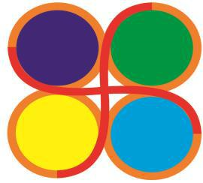

**Computer Department**

**Government Polytechnic, Ahmedabad**

**2016 – 2017**

**CERTIFICATE**

This is to certify that the project entitled **EVENT MANAGEMENT SYSTEM** submitted in partial fulfillment of the requirement of the degree of Diploma in Computer Engineering is a result of the bona fide work carried out by

**Parmar Mansi Ganpatbhai - (146170307532)**

**Prajapati Kalpesh Amrutbhai - (146170307542)**

**Yadav Divyang Nandkishor - (146170307555)**

During the year 2016 – 2017

Internal Guide Head of Department

Smt. Rekha M. Shah Mr. H. R. Parmar



**Computer Department**

**Government Polytechnic, Ahmedabad.**

**2016 – 2017**

**ACKNOWLEDGEMENT**

* This satisfaction that accompanies that the successful completion of any task would be incomplete without the mention of people whose ceaseless co-operation made it possible, whose constant guidance and encouragement crown all efforts with success. We are grateful to our project guide **Smt. Rekha M. Shah** for the guidance, inspiration and constructive suggestions that helpful us in the preparation of this project. We also thank our colleagues who have helped in successful completion of the Project.
* We extend our heartfelt thanks to **Prof. H. R. Parmar, Head of Computer Department** for his co-operation in our project work.
* We cannot forget to express our thanks to the **Entire staff** of our Department and **Colleagues** for providing us a helping arm during the project work.

**Parmar Mansi G.**

**Prajapati Kalpesh A.**

**Yadav Divyang N.**

**Abstract**

* This project is aimed provide the customers facility to book Event online, through which they can book event anytime, anywhere.
* E-Event Booking System is basically made for providing the customer an anytime and anywhere service for booking the entire event and to gather information about the Events online. The user can easily be able to know about the All events Booked or not and then make the choice. And it’s also selecting the different types of packages like Ready or Customize.
* Admin can use the system to insert and delete the data (e.g. Event description, timetable) which will update the webpage (Webpage are dynamic page, changing according to the data in database). Also, admin can check the statistic information from the system.
* It maintains two levels of the users :

1. Admin level
2. User level

**Index**

|  |  |  |
| --- | --- | --- |
| **Chapter No.** | **Title** | **Page No** |
| Chapter 1 | Introduction | 06 |
|  | 1.1 Project Profile | 07 |
|  | 1.2 Hardware Requirement | 08 |
|  | 1.3 Software Requirement | 08 |
| Chapter 2 | Literature Survey | 09 |
|  | 2.1 Existing System | 10 |
|  | 2.2 Need for a new system | 10 |
|  | 2.3 Process Model | 11 |
| Chapter 3 | Proposed Website | 13 |
|  | 3.1 Introduction | 14 |
|  | 3.2 Purpose | 14 |
|  | 3.3 Advantages | 15 |
|  | 3.4 System Modules | 15 |
| Chapter 4 | System Design | 16 |
|  | 4.1 System Flow Diagram | 17 |
|  | 4.2 Entity Relationship Diagram(ERD) | 19 |
|  | 4.3 Data Flow Diagram(DFD) | 22 |
|  | 4.4 Use Case Diagram | 29 |
|  | 4.5 Activity Diagram | 33 |
|  | 4.6 Data Dictionary | 40 |
| Chapter 5 | Project Implementation | 46 |
|  | 5.1 Screen shots (User Panel) | 47 |
|  | 5.2 Screen shots (Admin Panel) | 65 |
| Chapter 6 | Testing | 68 |
|  | 6.1 Risk Analysis | 69 |
|  | 6.2 Risk Management | 72 |
|  | 6.3 System Testing | 73 |
|  | 6.4 Test Cases | 77 |
| Chapter 7 | Conclusion and Future Scope | 80 |
|  | 7.1 Limitations of our Project | 81 |
|  | 7.2 Conclusion | 81 |
|  | 7.3 Future Scope | 81 |
| References and Bibliography | | |

**Chapter: 1**

**Introduction**

**1.1 Project Profile**

|  |  |
| --- | --- |
| **PROJECT TITLE:** | **EVENT MANAGEMENT SYSTEM:** |
| FRONT END: | Eclipse LUNA, Java 1.8 |
| BACK END: | MySql 5.0.51b |
| WEB SERVER | Tomcat Apache 8 |
| SUPPORTING TOOLS TO DEVELOP WEBSITE | HTML 5, CSS 3, JQuery, JavaScript, Bootstrap 3 |
| INTERNAL GUIDE: | Smt. Rekha M. Shah |
| PROJECT DURATION: | 1 YEAR |
| TEAM SIZE: | 3 MEMBERS |

**1.2 Hardware Requirement**

* Processor: I3 or Higher version
* RAM: 2 GB or Higher
* Disk Space: 25 GB (Minimum)

**1.3 Software Requirement**

* Operating System: Windows, Linux, Macintosh, etc.
* Browser: Chrome, Firefox, Internet Explorer, Safari, Opera, etc.

**Chapter – 2**

**Literature Survey**

**2.1 About existing system**

* The Existing system for Event management is a manual process.
* All this requires more time and labor work.
* This also gives root to lack of coordination, follow-ups and manual errors. Moreover, the data collected may be inconsistent, redundant and servicing a remote client will become impossible.
* Events to be organized at multiple locations become a tedious task.
* The burden over both the client and the employee increases and gives form to confusions and erroneous data.
* This section deals with the concept of system analysis, which is the primary phase of the software development.
* Existing System does not provide accurate information.
* It is not an easy task because many people need to be satisfied and many conflicts resolved.
* Involves more manual work Time consuming

**2.2 Need for the new system**

* The system used to provide a facility to Client to book an event very easily and any location.
* A new system is provide accurate information of Event Management, Such as

1. Venue Selection,
2. Food Selection,
3. Theme Selection,
4. Ready and Customize Package
5. Online Payment.

* The new System will cut-down the cost such as Paper and Stationary cost.

**2.3 Process Model:**

* The term process model is used in various contexts. For example, in business process modeling the enterprise process model is often referred to as the business process model. Abstraction level for processes.

**Iterative Waterfall model**

* The first three phases of the example iterative model is in fact an abbreviated form of a sequential V Model or waterfall Model of development.
* Each cycle of the model produces software that requires testing at the unit level, for software integration, for system integration and for acceptance.



**Benefits of iterative waterfall model**

* In iterative model we can only create a high-level design of the application before we actually begin to build the product and define the design solution for the entire product. Later on we can design and built a skeleton version of that, and then evolved the design based on what had been built.
* In iterative model we are building and improving the product step by step. Hence we can track the defects at early stages.
* This avoids the downward flow of the defects.
* In iterative model we can get the reliable user feedback. When presenting sketches and blueprints of the product to users for their feedback, we are effectively asking them to imagine how the product will work.
* In iterative model less time is spent on documenting and more time is given for designing.

**Chapter: 3**

**Proposed Website**

**3.1 Project introduction**

* Online Event Management System is an online event management system website project that serves the functionality of an event manager.
* The system allows only registered users to login and new users are allowed to register on the application.
* This is proposed to be a web application. The project provides most of the basic functionality required for an event.
* It allows the user to select from a list of event types. Once the user enters an event type Wedding, Opening Ceremony, Birthday Party, etc. the system then allows the user to select the date and time of event, place and the event equipment’s.
* All this data is logged in the database and the user is given a receipt number for his booking.
* This data is then sent to the administrator (website owner) and they may interact with the client as per his requirements and his contact data stored in the database.

**3.2 Purpose**

* This web based application system can be implemented in hotels, Hall for booking events.
* The system can also be used as website to promote the entire Event booking places.
* The user gets all the resources at a single place instead of wandering around for these. This system is effective and saves time and cost of the users.

## ****3.3 Features of Event Management System:****

* Scheduling of resources utilized in event
* Online registration of Attendee
* Streamline workflow of all events
* Online mail verification code
* Add to cart the selected item
* Management of wait list about over sold events
* Automation of notifications about events
* No extra charges of transaction & invoices.
* Improve visiting experience of attendees.

**3.4 Event management system modules**

* **Administrator module**
* Sign-In
* View/Update/Delete profile Details
* View/Update/Delete User Details
* Manage Food
* View/Update Booking Details
* Cancel Event (T&C)
  + **User module**
* Sign-up / Sign-in
* View/Update/Delete Profile Details
* Select Event And Venue And Date
* Select Package
  + Customize Package
  + Ready Package
* Book Event
* Payment (PayPal)
* View Confirmation Mail
* Cancel Event (T&C)

**Chapter-4**

**System Design**

**4.1 System flow chart:**



**4.2 ER diagram**

* An entity relationship diagram (ERD) shows the relationships of entity sets stored in a database. An entity in this context is a component of data. In other words, ER diagrams illustrate the logical structure of databases.
* An entity relationship diagram (ERD) shows the relationships of entity sets stored in a database.
* An entity in this context is a component of data. In other words, ER diagrams illustrate the logical structure of databases.
* At first glance an entity relationship diagram looks very much like a [flowchart](https://www.smartdraw.com/flowchart/).
* It is the specialized symbols, and the meanings of those symbols, that make it unique.

### ER Components

## Entity

* Entities are represented by means of rectangles. Rectangles are named with the entity set they represent.



## Attributes

* Attributes are the properties of entities. Attributes are represented by means of ellipses. Every ellipse represents one attribute and is directly connected to its entity (rectangle).



## Relationship

* Relationships are represented by diamond-shaped box. Name of the relationship is written inside the diamond-box. All the entities (rectangles) participating in a relationship, are connected to it by a line.

1. One-to-one
2. One-to-many
3. Many-to-one
4. Many-to-many

* **USE OF ER diagram**
* An entity relationship model, also called an entity-relationship (ER) diagram, is a graphical representation of entities and their relationships to each other, typically used in computing in regard to the organization of data within databases or information systems.
* Then lines or other symbols can be used to represent the relationship between entities, and text can be used to label the relationships. Finally, cardinality notations define the attributes of the relationship between the entities.

* **E-R Diagram:**



**4.3 DFD Diagram**

* A Data flow diagram (DFD) is a graphical representation of the "flow" of data through an information system, modeling its process aspects.
* A DFD is often used as a preliminary step to create an overview of the system, which can later be elaborated.
* This context-level DFD is next "exploded", to produce a Level 1 DFD that shows some of the detail of the system being modeled.
* The Level 1 DFD shows how the system is divided into sub-systems (processes), each of which deals with one or more of the data flows to or from an external agent, and which together provide all of the functionality of the system as a whole.
* It also identifies internal data stores that must be present in order for the system to do its job, and shows the flow of data between the various parts of the system.

### DFD Components

* DFD can represent Source, destination, storage and flow of data using the following set of components -
* **Entities** - Entities are source and destination of information data. Entities are represented by rectangles with their respective names.



* **Process** - Activities and action taken on the data are represented by Circle or Round-edged rectangles.



* **Data Storage** - There are two variants of data storage - it can either be represented as a rectangle with absence of both smaller sides or as an open-sided rectangle with only one side missing.



* **Data Flow** - Movement of data is shown by pointed arrows. Data movement is shown from the base of arrow as its source towards head of the arrow as destination.



* **Use of DFD diagram**
* A data flow diagram (DFD) is a graphical representation of the "flow" of data through an information system, modeling its process aspects.
* A DFD is often used as a preliminary step to create an overview of the system, which can later be elaborated.

**Context Level (Level-0):**



**Level 1: Admin**



**Level-1 User**



**Level 2: 2.4.0 Packages**



**Level 2: 2.5.0 Booking**



**4.4 Use-case Diagram**

* Use case diagrams are usually referred to as behavior diagrams used to describe a set of actions (use cases) that some system or systems (subject) should or can perform in collaboration with one or more external users of the system (actors).
* Each use case should provide some observable and valuable result to the actors or other stakeholders of the system.
  + **Actor**
* An actor represents a role that an outsider takes on when interacting with the business system. For instance, an actor can be a customer, a business partner, a supplier, or another business system.



* + Instead of a stick figure, other symbols can be used as well, if they fit the characteristics of the actor and lead to practical, easy-to-read diagrams.
* **Business Use Case**
* A business use case describes the interaction between an actor and a business system, meaning it describes the functionality of the business system that the actor utilizes:



* A business use case is described from the actor's perspective. Apart from the special use of the business use case as a use case within a business system, there is no difference between the business use case and a 'normal' use case.
* **Include Relationship**
* They include relationship is a relationship between two business use cases that signifies that the business use case on the side to which the arrow points is included in the use case on the other side of the arrow.
* This means that for one functionality that the business system provides, another functionality of the business system is accessed.



* At times, the direction of the arrow can be confusing; the relationship has to be read alongside the direction of the arrow (check-in includes issuing the boarding pass).
* **System**



|  |
| --- |
|  |
|  |

* The scope of a system can be represented by a system (shape), or sometimes known as a system boundary. The use cases of the system are placed inside the system shape, while the actors who interact with the system are put outside the system.
* The use cases in the system make up the total requirements of the system.
* **USE OF Use case diagram**
* Use case diagrams are usually referred to as behavior diagrams used to describe a set of actions (use cases) that some system or systems (subject) should or can perform in collaboration with one or more external users of the system (actors).





**4.5 Activity diagram**

* **Activity diagrams** are graphical representations of workflows of stepwise activities and actionswith support for choice, iteration and concurrency. In the Unified Modeling Language, activity diagrams are intended to model both computational and organizational processes (i.e. workflows).
* Activity diagrams show the overall flow of control.
* Activity diagrams may be regarded as a form of flowchart. Typical flowchart techniques lack constructs for expressing concurrency.
* However, the join and split symbols in activity diagrams only resolve this for simple cases. The meaning of the model is not clear when they are arbitrarily combined with decisions or loops.

### Activity Diagram Components

##### **Initial State or Start Point:**

* A small filled circle followed by an arrow represents the initial action state or the start point for any activity diagram. For activity diagram using swim lanes, make sure the start point is placed in the top left corner of the first column.

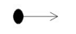

##### **Activity or Action State:**

* An action state represents the non-interruptible action of objects. You can draw an action state in Smart Draw using a rectangle with rounded corners.



##### **Action Flow:**

* Action flows, also called edges and paths, illustrate the transitions from one action state to another. They are usually drawn with an arrowed line.



##### **Decisions and Branching:**

* A diamond represents a decision with alternate paths.
* When an activity requires a decision prior to moving on to the next activity, add a diamond between the two activities.
* The outgoing alternates should be labeled with a condition or guard expression. You can also label one of the paths "else."



##### **Final State or End Point:**

* An arrow pointing to a filled circle nested inside another circle represents the final action state.

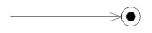

* **Use of Activity:**
* The basic usage of activity diagram is similar to other four UML diagrams. The specific usage is to model the control flow from one activity to another.
* This control flow does not include messages.
* The activity diagram is suitable for modeling the activity flow of the system.

**Login:**



**Registration:** 

**Profile:**

**Book:**

**4.6 Data Dictionary**

* A set of information describing the contents, format, and structure of a database and the relationship between its elements, used to control access to and manipulation of the database.

1. Table name :Event Master

Primary key: Event_id

Foreign key:

|  |  |  |  |
| --- | --- | --- | --- |
| **Field_Name** | **Data Type** | **Constraint** | **Description** |
| Event_id | Int (20) | Primary Key | Unique for each Event |
| Event Name | Varchar(20) | Not Null | Event Name |
| Description | Varchar(50) | Not Null | Description of Event |
| Photo | Varchar(50) | Not Null | Event Photo |
| Theme Photo | Varchar(50) | Not Null | Theme Photo |

1. Table name: Theme Master

Primary key: Theme_id

Foreign key: Event_id

|  |  |  |  |
| --- | --- | --- | --- |
| **Field_Name** | **Data Type** | **Constraint** | **Description** |
| Theme_id | Int (20) | Primary key | Unique for each Theme |
| Event_id | Int (20) | Foreign key | Unique for each Event |
| Theme Name | Varchar(20) | Not null | Theme name |
| Description | Varchar(50) | Not null | Description of Event |
| Basic Price | Int (30) | Not null | Price of Event |
| Photo | Varchar(50) | Not null | Photo of Theme |

1. Table name: Slider Master

Primary key: Theme_id

Foreign key: Event_id

|  |  |  |  |
| --- | --- | --- | --- |
| **Field_Name** | **Data Type** | **Constraint** | **Description** |
| Silder_Id | Int(20) | Primary key | Unique for each Theme |
| Event_id | Int(20) | Foreign key | Unique for each Event |
| Photo | Varchar(20) | Not null | Event Photo for slider |

1. Table name: Customer Master

Primary key: Customer_id

Foreign key:

|  |  |  |  |
| --- | --- | --- | --- |
| **Field_Name** | **Data Type** | **Constraint** | **Description** |
| Customer_id | Int(12) | Primary key | Unique for each customer |
| Customer name | Varchar(20) | Not null | Unique for each customer |
| Mobile no | Int(12) | Not null | Mobile |
| Email | Varchar(20) | Not null | Email |
| Password | Varchar(20) | Not null | Encrypted password |
| Date of Registration | Date | Not null | Date |

1. Table name: venue master

Primary key: venue_id

Foreign key:

|  |  |  |  |
| --- | --- | --- | --- |
| **Field_Name** | **Data Type** | **Constraint** | **Description** |
| Venue id | Int(12) | Primary key | Unique for each venue |
| Area | Int(12) | Not null | Unique for each venue |
| Venue name | Varchar(20) | Not null | Unique for each venue |
| Address | Varchar(50) | Not null | Address |
| Email | Varchar(50) | Not null | Person name |
| Basic Price | Int (12) | Not null | Person mobile |
| Mobile No | Int (20) | Not null | Email |
| Photo | Varchar(50) | Not null | Basic price of venue |
| Capacity | Int(10) | Not null | Capacity of venue |

1. Table name: Ready package

Primary key: Ready_package_id

Foreign key: Event_id

|  |  |  |  |
| --- | --- | --- | --- |
| **Field_Name** | **Data Type** | **Constraint** | **Description** |
| Ready Package id | Int(20) | Primary key | Unique for each Event |
| Event id | Int(20) | Foreign key | Unique for each Event |
| Menu detail | Varchar(100) | Not null | Detail Of Food |
| Price | Int(50) | Not null | Price of package |
| Photo | Varchar(20) | Not null | Discount |

1. Table name: Customize Package

Primary key: Order_id

Foreign key:

|  |  |  |  |
| --- | --- | --- | --- |
| **Field_Name** | **Data Type** | **Constraint** | **Description** |
| Order_id | Int(10) | Primary key | Unique for each  Order |
| Soup_id | Int(5) | null | Soup id |
| Starter_id | Int(5) | null | Starter id |
| Roti_id | Int(5) | null | Roti id |
| Sabji_id | Int(5) | null | Sabji id |
| Dal_id | Int(5) | null | Dal id |
| Rice_id | Int(5) | null | Rice id |
| Ice_cream_id | Int(5) | null | Ice-cream id |
| Chinese_id | Int(5) | null | Chinese id |
| Cake_id | Int(5) | null | Cake id |

1. Table name: Order Master

Primary key: order_id

Foreign key:

|  |  |  |  |
| --- | --- | --- | --- |
| **Field_Name** | **Data Type** | **Constraint** | **Description** |
| Order_id | Int(20) | Primary key | Unique for each Event |
| Theme_id | Int(20) | Foreign key | Unique for each Theme |
| Event_id | Int(20) | Foreign key | Unique for each Event |
| Venue_id | Int(20) | Foreign key | Unique for each Venue |
| Customer_id | Int(20) |  |  |
| Date of Event | Date | Not null | Date of Event |
| No of person | Int(3) | Not null | No of person |
| General total | Int(20) | Not null | Total |
| Pacakge_id | Int(10) | Not null | Pacakge_id R(ready) and C(customize) |
| Package Type | Varchar(1) | Not null | Package Type Ready Package and customize Package |

1. Table name:Food_Categoire

Primary key: Categorie_id

Foreign key:

|  |  |  |  |
| --- | --- | --- | --- |
| **Field_Name** | **Data Type** | **Constraint** | **Description** |
| Categorie_id | Int(10) | Primary Key | Unique for each Category |
| Category | Varchar(20) | Not null | Category Name |
| Photo | Varchar(20) | Not null | Photo for Food |

1. Table name: Food Item

Primary key: Food_item_id

Foreign key: Categorie_id

|  |  |  |  |
| --- | --- | --- | --- |
| **Field_Name** | **Data Type** | **Constraint** | **Description** |
| Food_item_id | Int(10) | Primary Key | Unique for each Food |
| Categorie_id | Int(10) | Foreign Key | Unique for each Category |
| Food_item_Name | Varchar(50) | Not null | Food Name |

1. Table name : Admin

|  |  |  |  |
| --- | --- | --- | --- |
| **Field_Name** | **Data Type** | **Constraint** | **Description** |
| User_Name | Varchar(20) | Not Null | User name |
| Password | Varchar(20) | Not Null | Password |

1. Table name:Addtocart

Primary key: Addtocart_id

Foreign key: Customer_id, Event_id, Theme_id, Venue_id

|  |  |  |  |
| --- | --- | --- | --- |
| **Field_Name** | **Data Type** | **Constraint** | **Description** |
| Addtocart_id | Int(11) | Primary Key | Unique for each Addtocart |
| Customer_id | Int(11) | Foreign key | Unique for each Customer_id |
| Event_id | Int(11) | Foreign key | Unique for each Event_id |
| Theme_id | Int(11) | Foreign key | Unique for each Theme_id |
| Venue_id | Int(11) | Foreign key | Unique for each Venue_id |
| Event Date | Date | Date | Date for Event |
| Person no | Int(11) | Not null | Unique for each Person no |
| Total Price | Int(11) | Not Null | Total Price |
| Pacakge_id | Int(11) | Not null | Unique for each Pacakge_id |
| Package name | Varchar(20) | Not null | Package name |

**Chapter: 5**

**Project Implementation**

**5.1 SNAP SHOTS**

* **User Site**

**User Site before Login**

1. **Home Page**

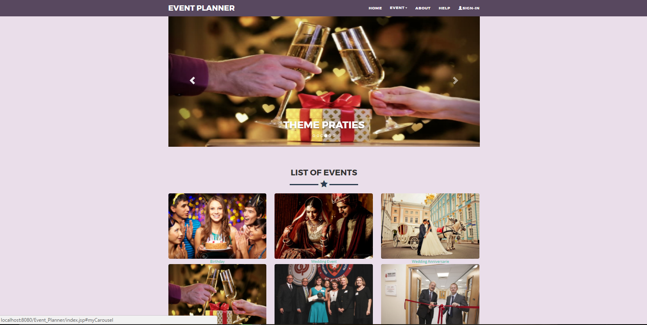

* This Page is Represent The Home Page

**2. Events Page:**

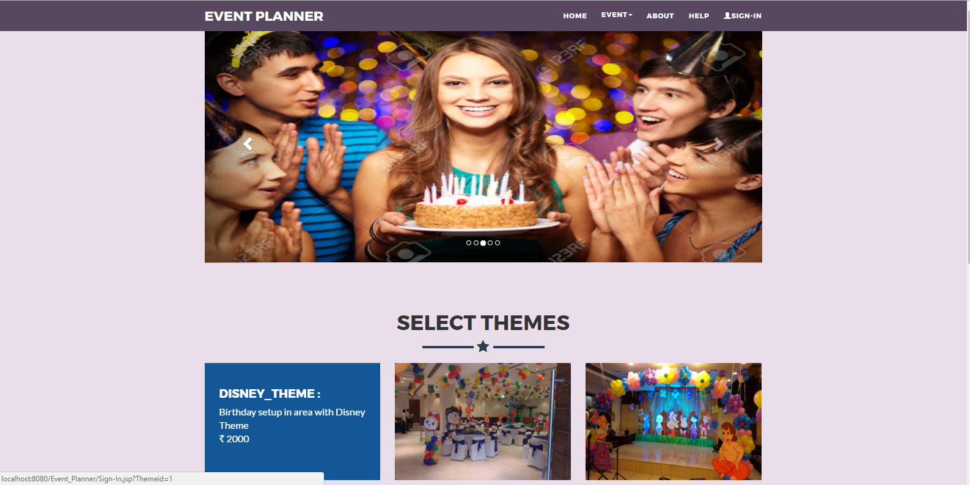

* This Page is Represent the Events of This website (Birthday, Wedding, Wedding anniversary, Theme Party, Award Ceremonies, Opening Ceremonies)

**3. about-us:**

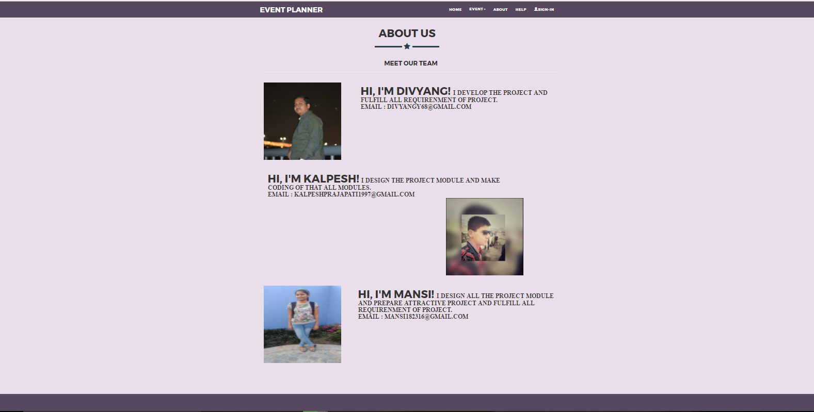

* This Page is giving the information about the Developers.

**4. Help:**

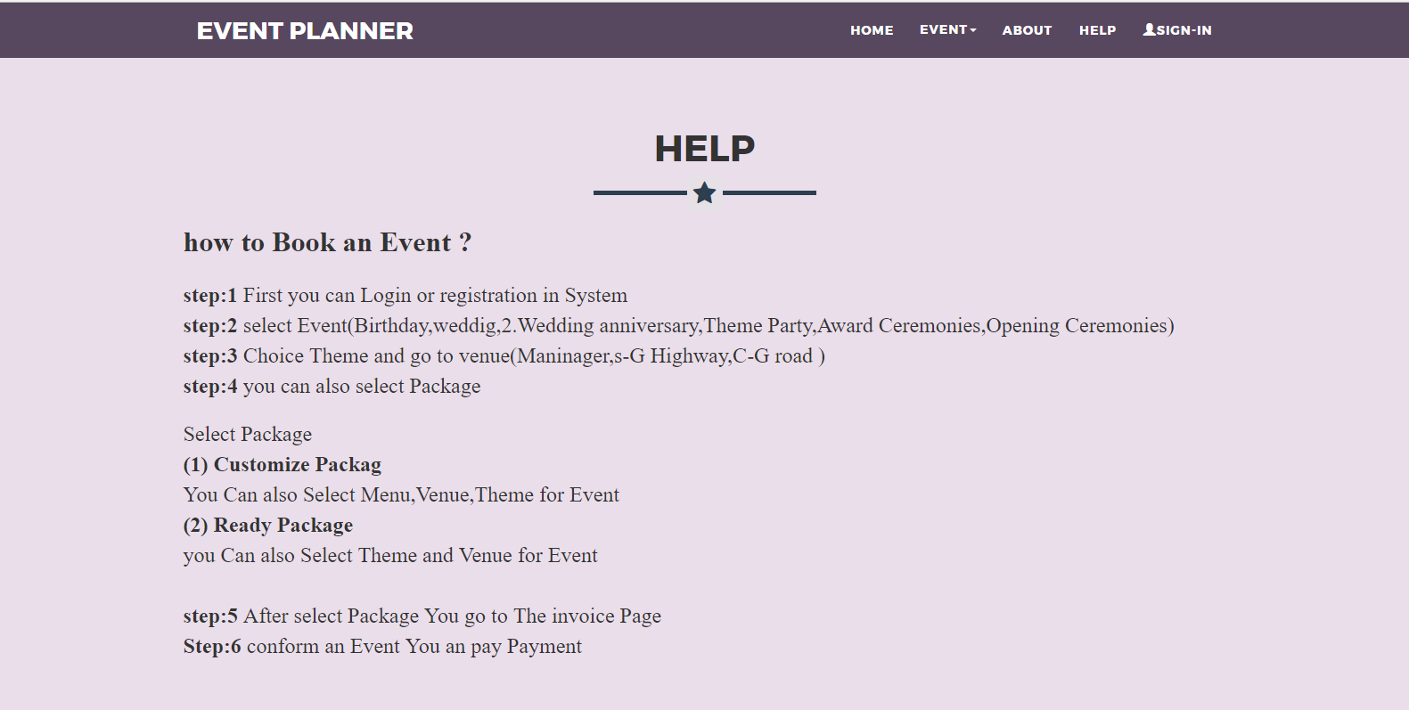

* This Page Give the information for How to Book an Event.

**5. Login Page:**

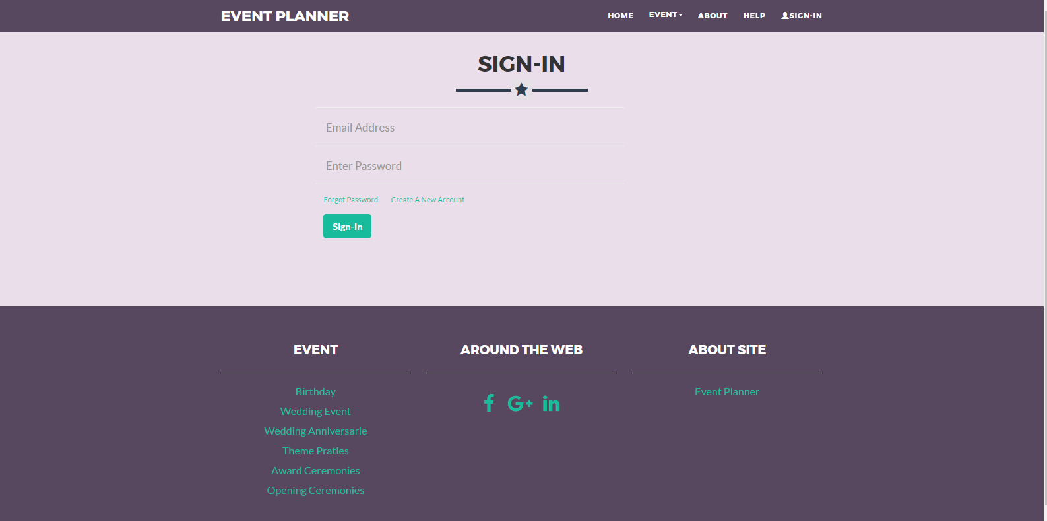

* This page Register User Login in this System.

**6. Registration Page:**

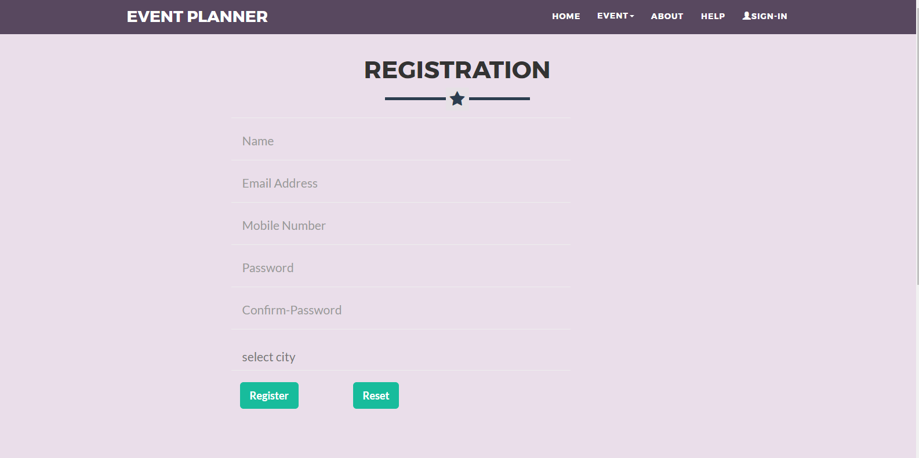

* Through this Page User can Register in website

**OTP Verification:**

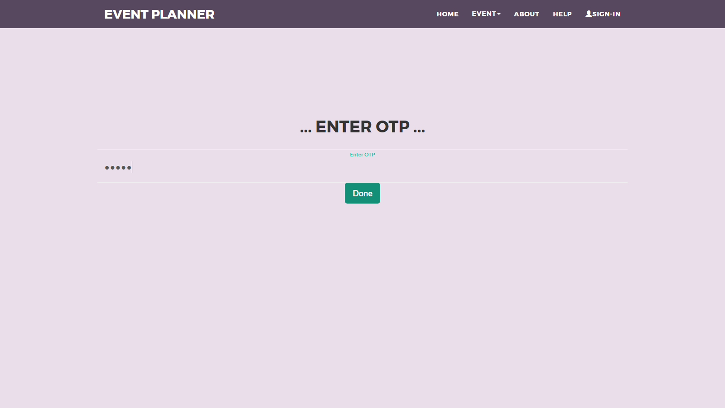

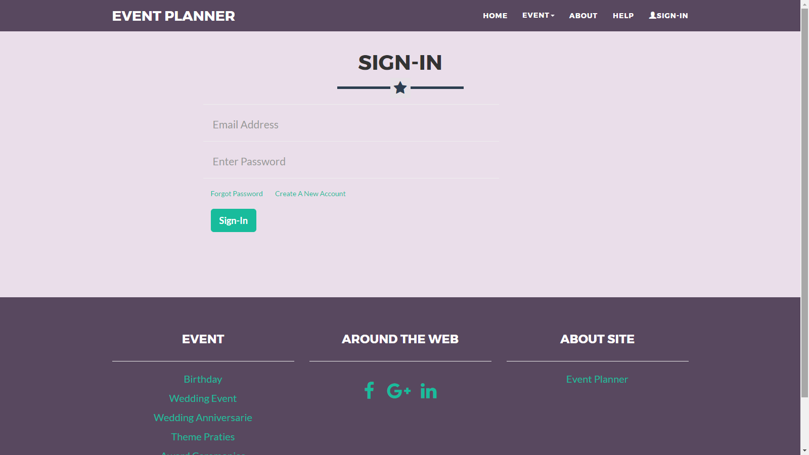

**Forgot Password:**

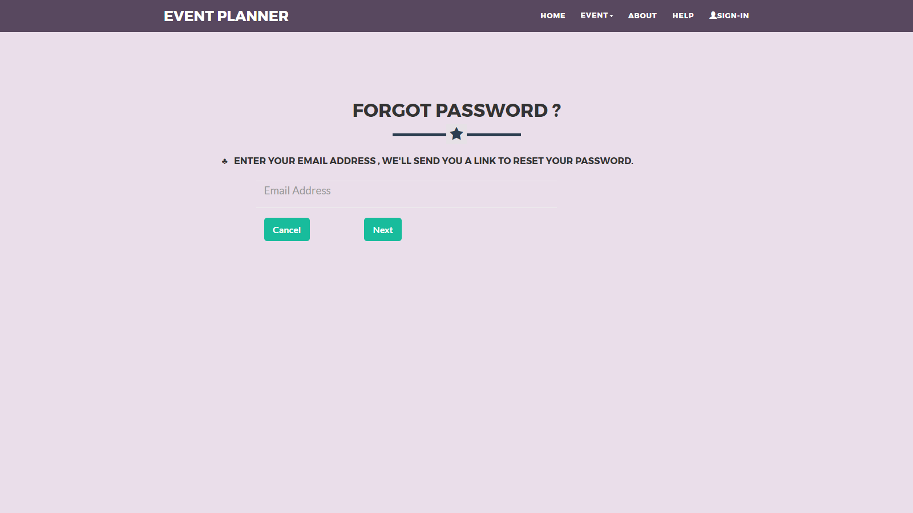

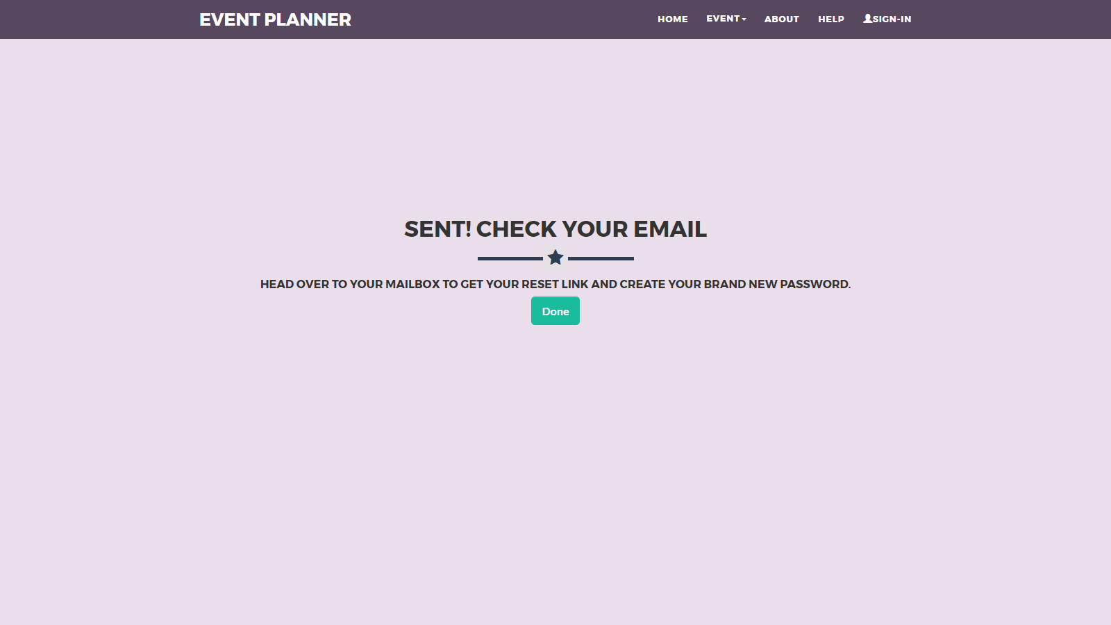

* **User Site After Login**

**1. Home Page:**



* This Page is Represent The Home Page

1. **Events Page (Birthday Event):**

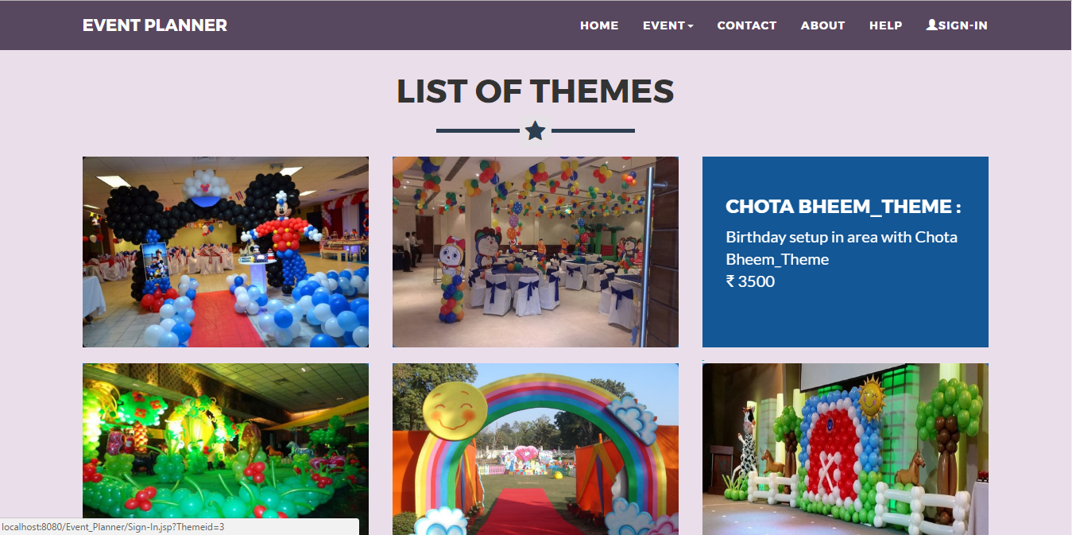

* This Page is Represent the Events and its Theme of This website (Birthday, Wedding, Wedding anniversary, Theme Party, Award Ceremonies, Opening Ceremonies).

1. **Venue Page:**

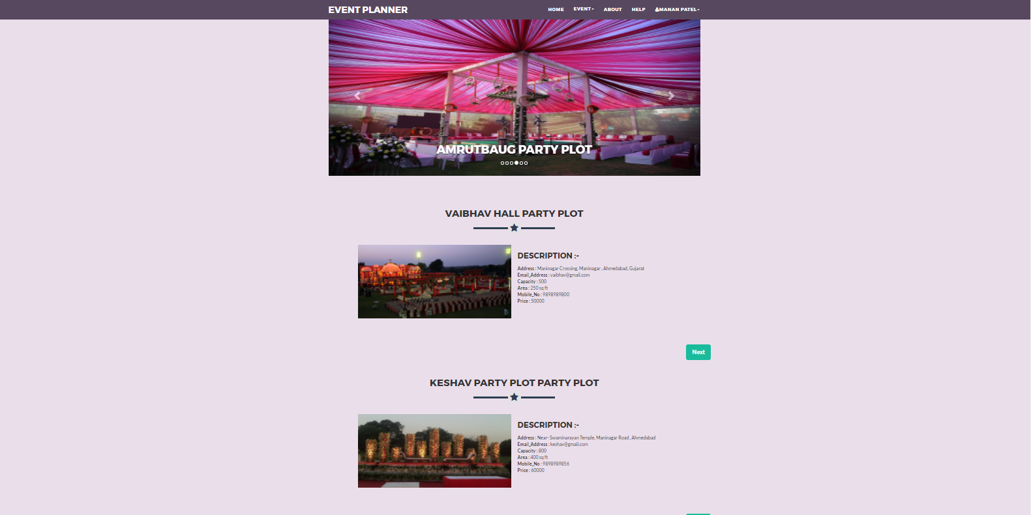

* This Page is Represent the Venue for our Event (Maninagar, S-G Highway, C-G road).

1. **Book Page:**

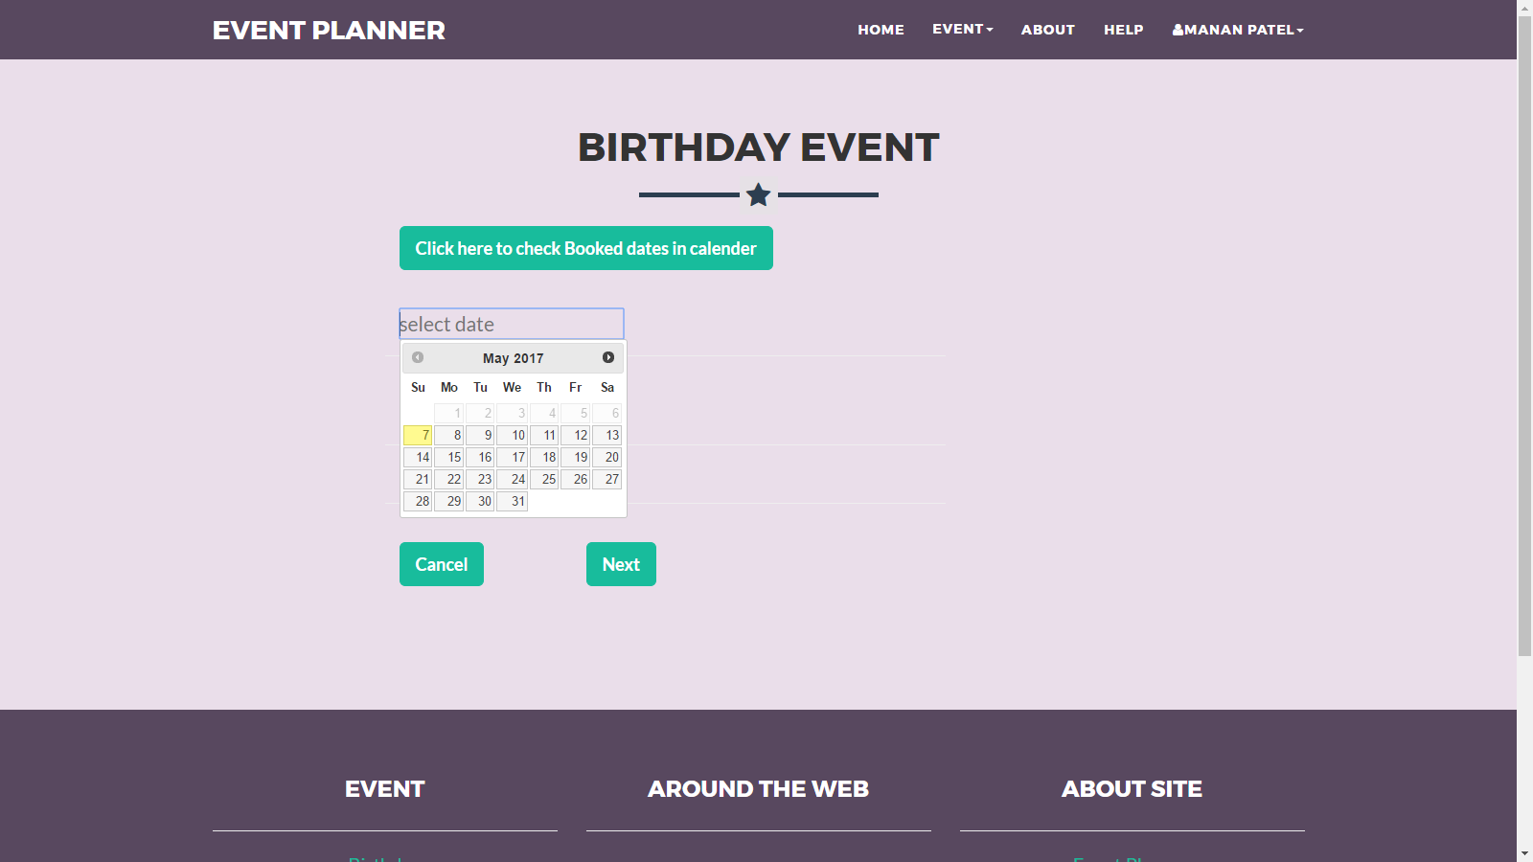

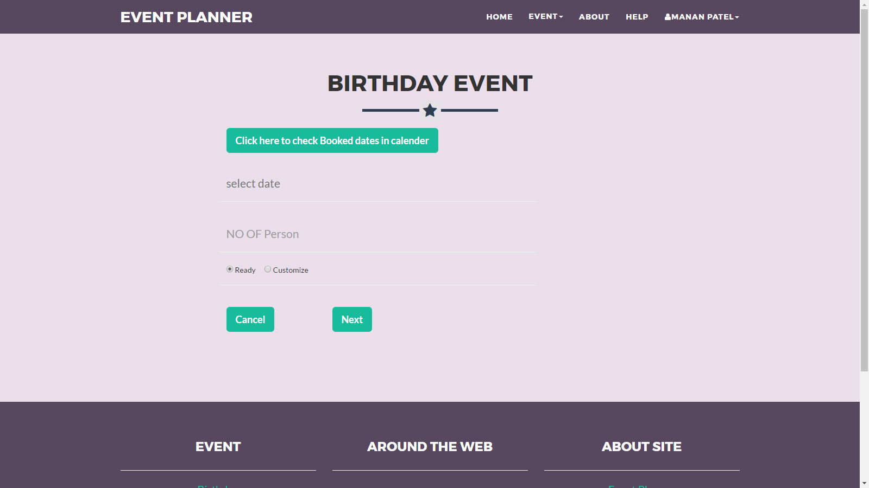

* This Page is Represent Who is select You like(Date, No. of person, Package)

**Ready-Made Page:**

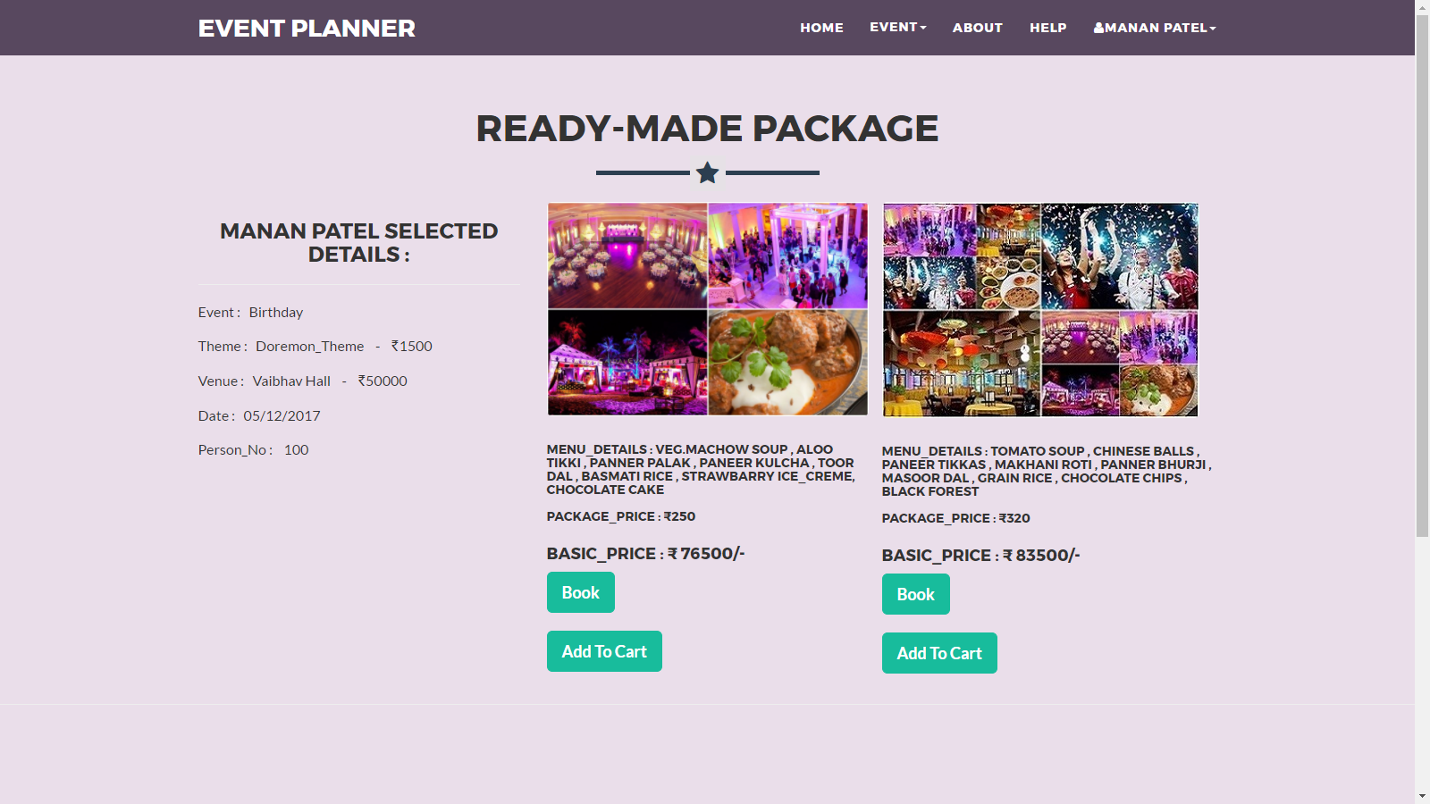

* Ready: This Page is Represent who is select you like (Event, Theme, Venue).

**Add-To-Cart:**

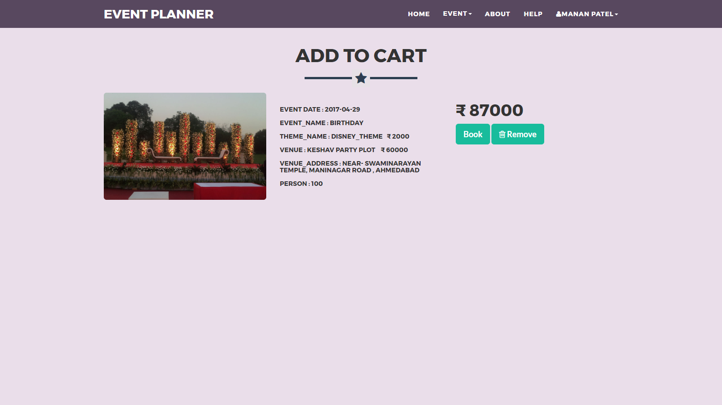

* If he/she need to store their event into add to cart so, he also press add button from ready-package frame.

**Customize Page:**

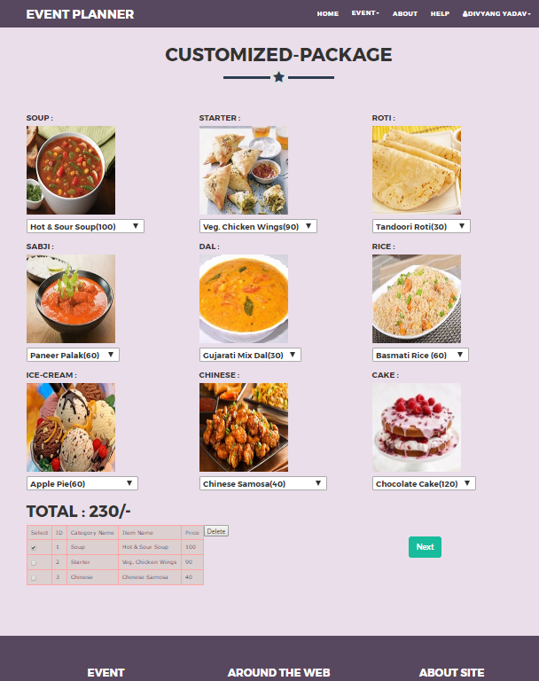

* Customize: This Page is Represent Who is select you Like (Event, Theme, Venue, and Food Menu).

1. **Invoice Page:**

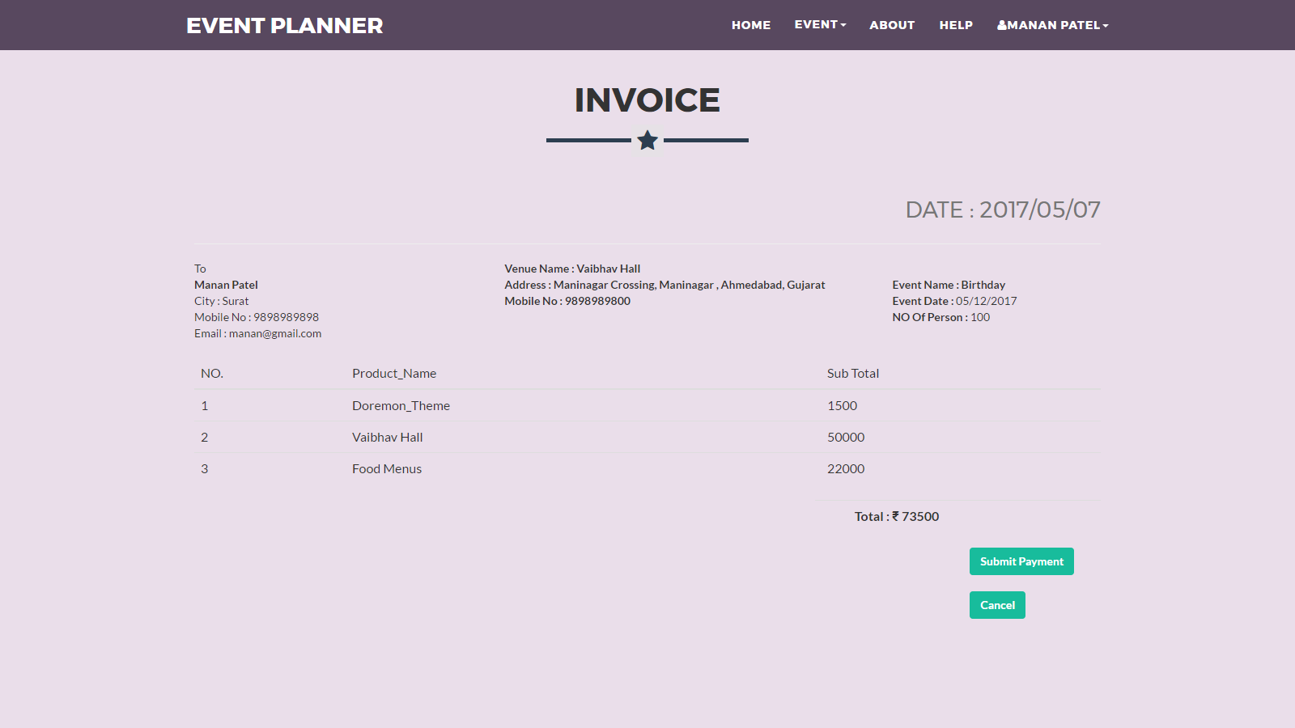

* This Page is Represent Who is Select You like (Event, Theme, Venue, and Package).

1. **Mail Invoice:**

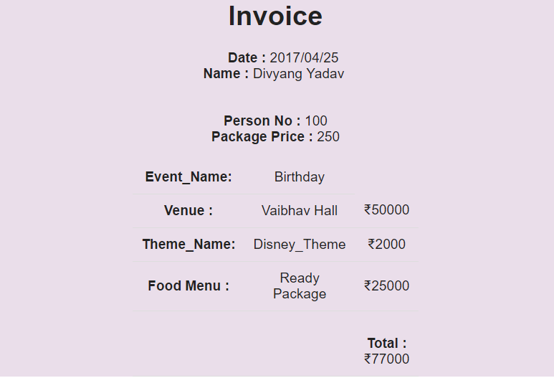

* This Page is Represent Send Bill via its registered Mail address.

1. **Check out History :**

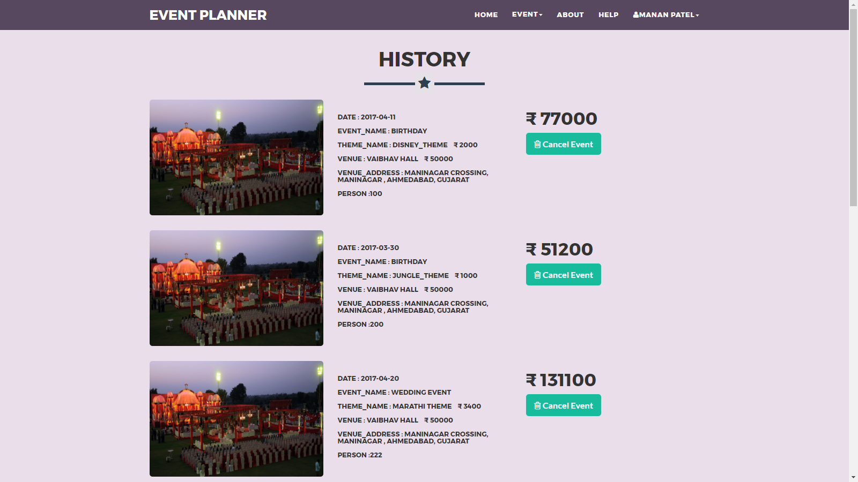

* Here, User Make History whenever Event it should be booked.
* **Admin Site**

1. **Home Page**

This Page is Represent the Home Page

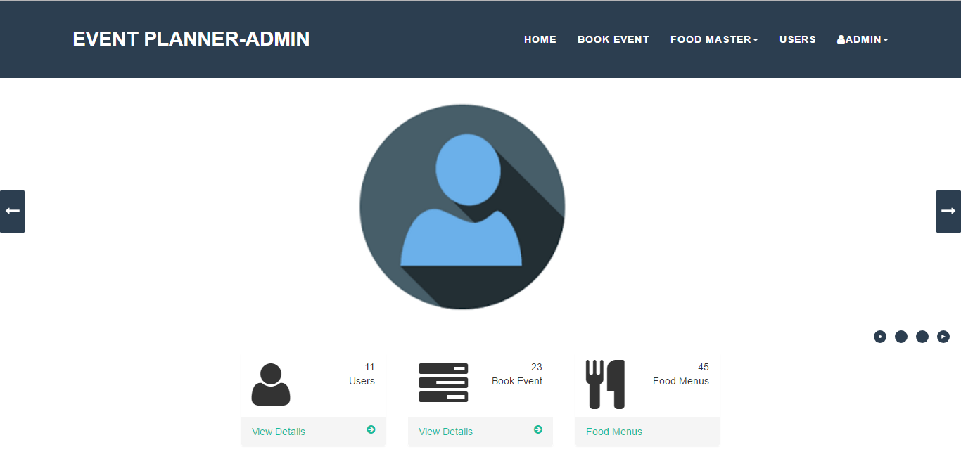

1. **Login**

Through this page Website Administrator can Login to the Admin Panel.

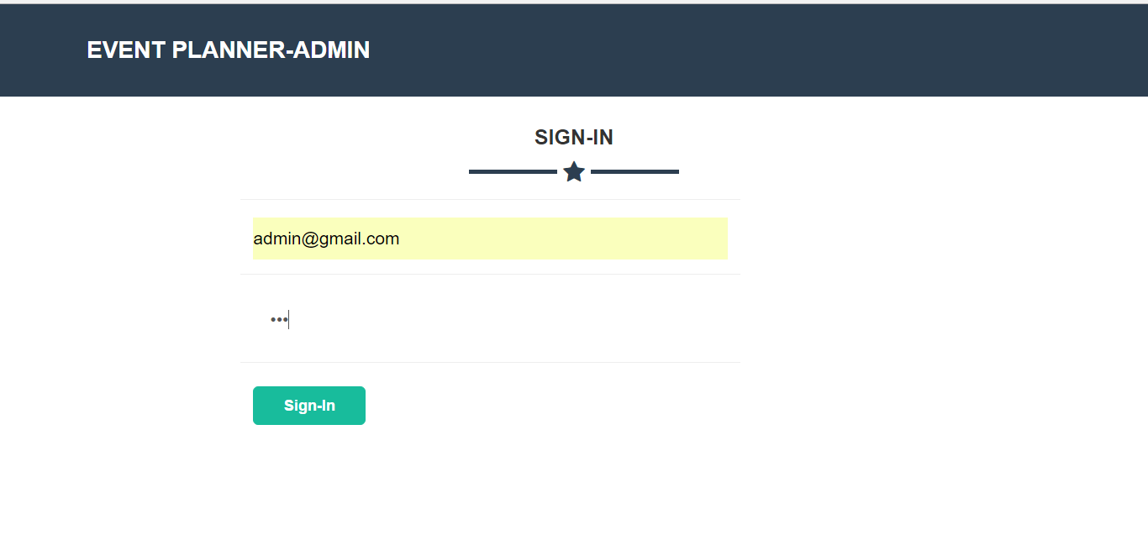

1. **Book Event**

This Page is represent the who user the Book in this Website

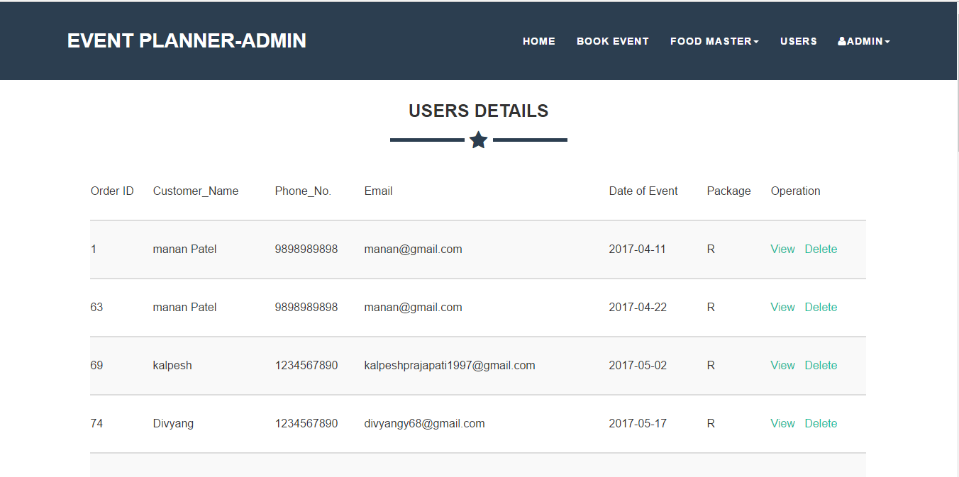

1. **Menu Master**

This Page Admin Add/update/delete The Menu Details.

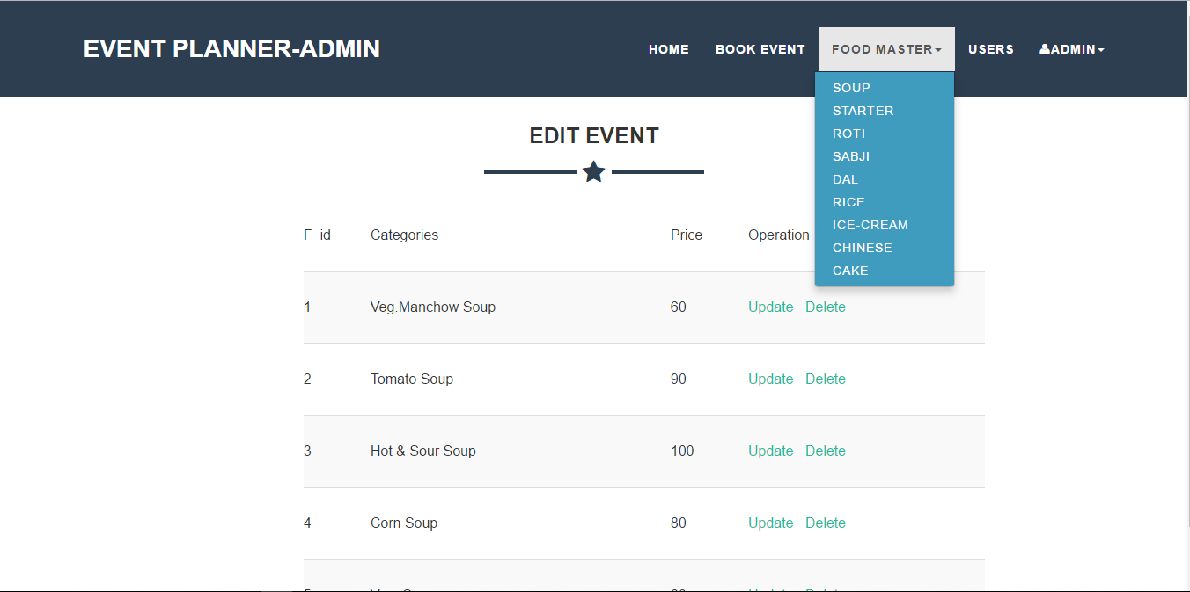

1. **Users Details**

This Page Admin Can see the who user can Register in website 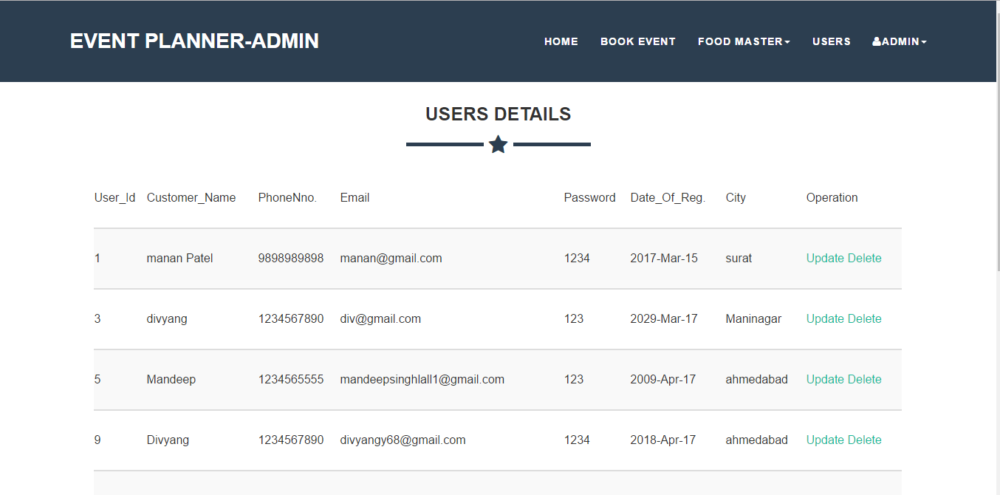

1. **Change Password**

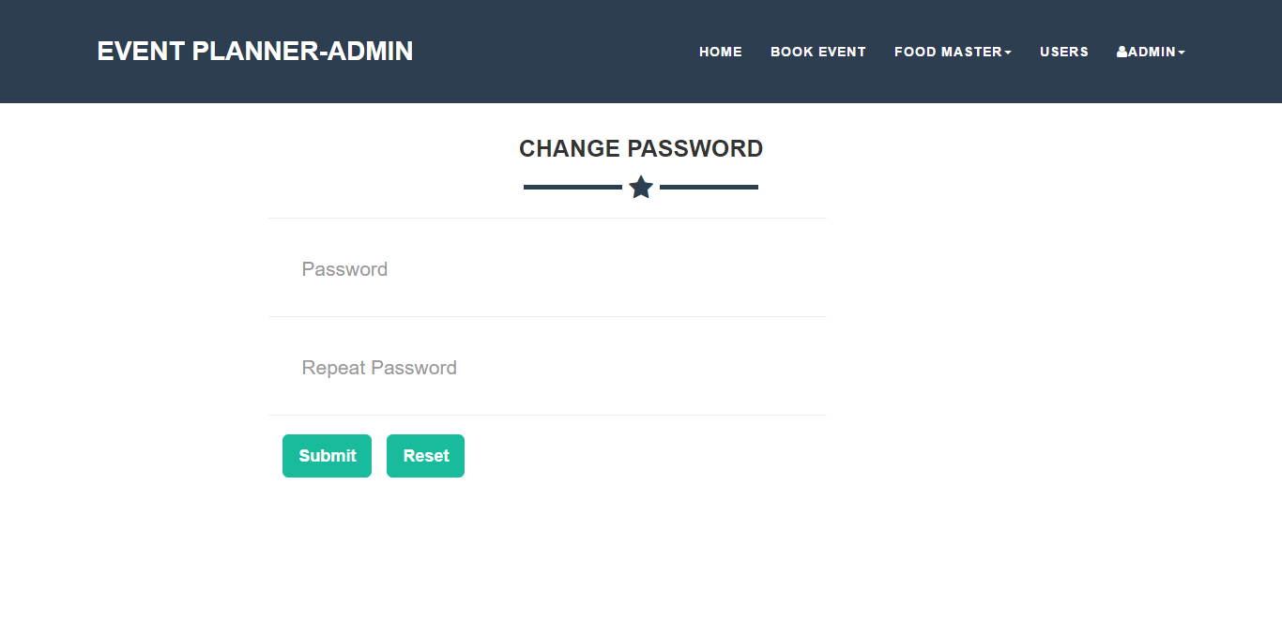

**Chapter: 6**

**Testing**

**6.1 Risk Analysis**

Risk analysis is the review of the risks associated with a particular event or action. It is applied to projects, information technology, security issues and any action where risks may be analyzed on a quantitative and qualitative basis. Risk analysis is a component of risk management.

Risks are generally of two types:

* Proactive Risk
* Reactive Risk

**6.1.1 Risk Identification**

Risk identification is the process of determining risks that could potentially prevent the program, enterprise, or investment from achieving its objectives. It includes documenting and communicating the concern.

**Risk Category: Schedule**

1. Schedule not realistic, only "best case".
2. Important task missing from the schedule.

**Risk Category: Requirement Risk**

1. Requirements have been base lined but continue to change.
2. Requirements are poorly defined, and further definition expands the scope of the project

**Risk Category: Project Management Risk**

1. PM has little authority in the organization structure and little personal power to influence decision-making and resources
2. Projects within the program often need the same resources at the same time

**Risk Category: Product/Technology Risk**

1. Development of the wrong user interface results in redesign and implementation.
2. Development of extra software functions that are not required (gold plating) extends the schedule.

**Risk Category: Customer Risk**

1. Customer insists on new requirements.
2. Customer review/decision cycles for plans, prototypes, and specifications are slower than expected.

**Proactive Risk Assessment Table:**

This are the proactive risks which we can consider during the project plan period so we can cop up with them easily and we can find the solution easily but we can find other proactive risks which we haven’t considered in the project plan :

|  |  |
| --- | --- |
| **Risk** | **Effect** |
| Possibility of because of some people we have lost the backup of some days | Serious |
| Possibility of because of Finance problem we have company we won’t get the full resources | Catastrophic |
| Possibilities that the Project manager leave the project | Serious |

**Reactive Risk Assessment Table:**

Proactive risks are most dangerous risk which we haven’t considered during the project period and to cop up with them is not easy. These kinds of risks are risks, so programmer must have been active to cop up with them smartly.

**Risk Estimation:**

Risk estimation attempts to rate each risk in two ways:

* The likelihood or probability that risk is real and.
* The consequences of the problems associated with the risk should it occurs.
* The project planner, along with other managers and technical staff, performs four risk projection steps:
* Establish a scale real that reflects the perceived likelihood of a risk.
* Delineate the consequences of the risk.
* Estimate the impact of the risk on the project and the product.
* Note the overall accuracy of the risk projection so that there will be no misunderstanding.

The intent if these steps are to consider risk in a manner that leads to prioritization. No software team has the resources to address every possible risk with the same degree of rigor. By prioritizing risk, the team can allocate resources where they will have the most impact.

**6.1.2 Risk Impact**

Risk impact assessment is the process of assessing the probabilities and consequences of risk events if they are realized. The results of this assessment are then used to prioritize risks to establish a most-to-least-critical importance ranking.

**6.2 Risk Management**

Risk management is the process of identifying, quantifying, and managing the risks that an organization faces. As the outcomes of business activities are uncertain, they are said to have some element of risk.  These risks include strategic failures, operational failures, financial failures, market disruptions, environmental disasters, and regulatory violations. Risk is a statistical concept that is measured using statistical concepts that are related to the unknown future. Almost all investments are exposed to it.

* **Process Model:**

**Iterative Waterfall model**

To solve actual problems in an industry setting

* The first three phases of the example iterative model is in fact an abbreviated form of a sequential V Model or waterfall Model of development.
* Each cycle of the model produces software that requires testing at the unit level, for software integration, for system integration and for acceptance.



* 1. **System Testing**

**6.3.1 Testing Principles:**

Following are testing principals which are used.

* All tests should be traceable to customer’s requirement.
* Tests should plan long before testing begins.
* Testing should begin in small and progressed towards testing in the large.
* Exhausting testing is not possible.
* To be most effective testing should be conducted by an independent third party.

**6.3.2 System Testing and Debugging:**

The phase of system development life cycle tests system design. Testing of system decides whether the newly designed system works properly or not. After the development of documentation manually about the system this checked, and if the system working property then it will be find out generated errors of problems and to find out its solution. This process is known as debugging.

For any software system testing means to check out it’s coding. If we are not getting proper or required output then we have to debug the system coding. So, the debugging is also a subpart of the testing selection. It the system runs correctly during testing of our project we have to face different types of errors. Especially, errors annoyed us but at last we solved it, successfully. Some of the errors are listed below with their cause and solution.

**6.3.3 Testing Objectives:**

There are several testing objectives. They are as follows:

* Testing is process of executing a program with the intent of finding an error.
* A good test case is one that has a high probability of finding an as yet undiscovered error.
* A successful test is one that uncovers an as yet undiscovered error.

**Testing:**

Testing requires understanding the software and what it is supposed to do. Then software testers must verify the correctness and completeness of the software. Testing verifies that the system meets its intended functionalities.

Correctness of software verifies that the software does what it is supposed to do correctly. Completeness verifies. That the software covers all aspects of the problem it tries to solve. Testing is usually performed by operating the software. In controlled Fashion to determine its correctness, completeness, robustness, and reliability. Software testing must be planned carefully to avoid wasting development time and resources. Testing begins “In the Small” and progress “To the large”. Initially individual components are crested using white box and black box techniques after the individual components have been tested and added to the system, integrating takes place. Once the full software product is copulated, system testing is performed.

**Testability:**

Software testability is simply how easily a computer program can be tested. The checklist t hat follows provides a set of characteristics that lead to testable software.

* Operability
* Observables
* Controllability
* Decomposability
* Simplicity
* Stability
* Understandability

Following are the attributes of the good test:

* A good test has a high probability of finding an error.
* A good test should be “best of breed”.
* A good test is not redundant.
* A good test would be neither too simple nor too complex.

**6.3.4 Model of Testing**

**1. Back-box Testing**

Black Box Testing, also known as Behavioral Testing, is a software testing method in which the internal structure/ design/ implementation of the item being tested is not known to the tester. These tests can be functional or non-functional, though usually functional.

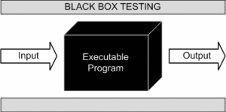

This method is named so because the software program, in the eyes of the tester, is like a black box; inside which one cannot see. This method attempts to find errors in the following categories:

* Incorrect or missing functions
* Interface errors
* Errors in data structures or external database access
* Behavior or performance errors
* Initialization and termination errors

**2. White-Box Testing**

White Box Testing (also known as Clear Box Testing, Open Box Testing, Glass Box Testing, Transparent Box Testing, Code-Based Testing or Structural Testing) is a software testing method in which the internal structure/ design/ implementation of the item being tested is known to the tester. The tester chooses inputs to exercise paths through the code and determines the appropriate outputs. Programming know-how and the implementation knowledge is essential. White box testing is testing beyond the user interface and into the nitty-gritty of a system.

White-box testing: Testing based on an analysis of the internal structure of the component or  
system.

White-box test design technique: Procedure to derive and/or select test cases based on an  
analysis of the internal structure of a component or system.

What do you verify in White Box Testing?

* White box testing involves the testing of the software code for the following:
* Internal security holes
* Broken or poorly structured paths in the coding processes
* The flow of specific inputs through the code
* Expected output
* The functionality of conditional loops
* Testing of each statement, object and function on an individual basis

The testing can be done at system, integration and unit levels of software development. One of the basic goals of white box testing is to verify a working flow for an application. It involves testing a series of predefined inputs against expected or desired outputs so that when a specific input does not result in the expected output, you have encountered a bug.

* 1. **Test Case**
* **Test Case: User Side**
* A test case is a set of test inputs, execution conditions, and expected results developed for a particular objective, such as to exercise a particular program path or to verify compliance with a specific requirement test cases are mentioned below in table.

**Module Name**: Registration

**Testing Date**: 10/4/2017

|  |  |  |  |
| --- | --- | --- | --- |
| **Case ID** | **Test Case** | **Expected Result** | **Result** |
| CS1 | Enter All User’s Information | Checking that all fields are filled, they are in correct format and email-id is unique | Pass |
| CS2 | Click on Register Button | Insert all User’s Information in Database and simultaneously send mail | Pass |
| CS3 | Click on Reset Button | Clear All Information of User In Registration Form | Pass |

**Module Name**: Login

**Testing Date**: 10/4/2017

|  |  |  |  |
| --- | --- | --- | --- |
| **Case ID** | **Test Case** | **Expected Result** | **Result** |
| CS1 | Enter Username and Password | Checking Username and Password | Pass |
| CS2 | Unsuccessful operation due to wrong Username and Password | It should display Login Screen again | Pass |
| CS3 | Successful Login into Account | Display Home Page of User according to User Type | Pass |
| CS4 | Successful Logout from Account | Logout from Account and displays Login Screen | Pass |

**Module Name**: Select Event (Step:-1)

**Testing Date**: 10/4/2017

|  |  |  |  |
| --- | --- | --- | --- |
| **Case ID** | **Test Case** | **Expected Result** | **Result** |
| CS1 | Select Event Category | Provides Event for particular category | Pass |
| CS2 | Select Theme | Not login (It should display Login Screen )Login Go to next page | Pass |
| CS3 | Select Venue | Select Venue , Provides Details of All Venue | Pass |

**Module Name**: Book (Step:-2)

**Testing Date**: 10/4/2017

|  |  |  |  |
| --- | --- | --- | --- |
| **Case ID** | **Test Case** | **Expected Result** | **Result** |
| CS1 | Enter All Book Information | Checking that all fields are filled, | Pass |
| CS2 | Click on Next Button | You selected Ready Package go to Ready Page you selected Customize package go to customize Page | Pass |

**Module Name**: Ready-Made Package (Step:-3)

**Testing Date**: 10/4/2017

|  |  |  |  |
| --- | --- | --- | --- |
| **Case ID** | **Test Case** | **Expected Result** | **Result** |
| CS1 | Select Ready-Made Package | Checking that all fields are filled, | Pass |
| CS2 | Click on Next Button | Go to The invoice Page | Pass |

**Module Name**: Customize-Made Package (Step:-3)

**Testing Date**: 10/4/2017

|  |  |  |  |
| --- | --- | --- | --- |
| **Case ID** | **Test Case** | **Expected Result** | **Result** |
| CS1 | Select Customize-Made Package | Checking that all fields are filled, | Pass |
| CS2 | Enter All menu Information | Checking that all fields are- filled, | Pass |
| CS3 | Click on Next Button | Go to the invoice page | Pass |

**Module Name**: Invoice (Step:-4)

**Testing Date**: 10/4/2017

|  |  |  |  |
| --- | --- | --- | --- |
| **Case ID** | **Test Case** | **Expected Result** | **Result** |
| CS1 | All Information is user selected is | Checking that all fields are- filled, | Pass |
| CS2 | Click on Payment Button | Go to the Payment Page | Pass |

* **Test Case: Admin Side**

**Module Name**: Admin Home

**Testing Date**: 10/4/2017

|  |  |  |  |
| --- | --- | --- | --- |
| **Case ID** | **Test Case** | **Expected Result** | **Result** |
| CS1 | Display all users, Book Event, Food menu | All User, Book Event, Food menu display successfully | Pass |

**Module Name**: Book Event

**Testing Date**: 10/4/2017

|  |  |  |  |
| --- | --- | --- | --- |
| **Case ID** | **Test Case** | **Expected Result** | **Result** |
| CS1 | All Information is user selected is | Checking that all fields are- filled, | Pass |
| CS2 | Admin can delete User | Successfully Delete | Pass |

**Module Name**: Food menu

**Testing Date**: 10/4/2017

|  |  |  |  |
| --- | --- | --- | --- |
| **Case ID** | **Test Case** | **Expected Result** | **Result** |
| CS1 | Admin can Update Food | Successfully Update | Pass |
| CS2 | Admin can Delete Food | Successfully Delete | Pass |

**Module Name**: Users

**Testing Date**: 10/4/2017

|  |  |  |  |
| --- | --- | --- | --- |
| **Case ID** | **Test Case** | **Expected Result** | **Result** |
| CS1 | All Information is user selected is | Checking that all fields are- filled, | Pass |
| CS2 | Delete User | Successfully Delete | Pass |

**Chapter: 7**

**Conclusion and Future Scope**

## ****7.1 Limitation of Our Project:****

* The proposed system is developed to overcome the short comings of the manual system, but still there are many limitations to this new system.
* The limitations are as follows:

1. This website is developed for a Six Events.
2. It doesn’t have the features like to City options, Desire-caterer and Halls, etc.
3. Many features can be made more dynamic.

## ****7.2 Futures Scope of Event Management System:****

* Add Modules for service provider (like Decorator, Caterer, etc.).
* Automation of notifications about events.
* Improve visiting experience of attendees.
* Add more payment option.
* Admin Add, Update, Delete Event

**7.3 Conclusion:**

* At the time submitting the report we have successfully designed the website to handle an Events.
* We have also designed our data dictionary to store most the data but when we will implement the system in the next semester, it may be possible that data dictionary may change,
* We have tried our best to make our website user friendly and useful to company.

**References and Bibliography**

* **Websites:-**

1. [WWW.GOOGLE.COM](http://WWW.GOOGLE.COM)
2. [WWW.WIKIPEDIA.COM](http://WWW.WIKIPEDIA.COM)

* **Book:-**

1. The complete Reference
2. E Balaguruswami